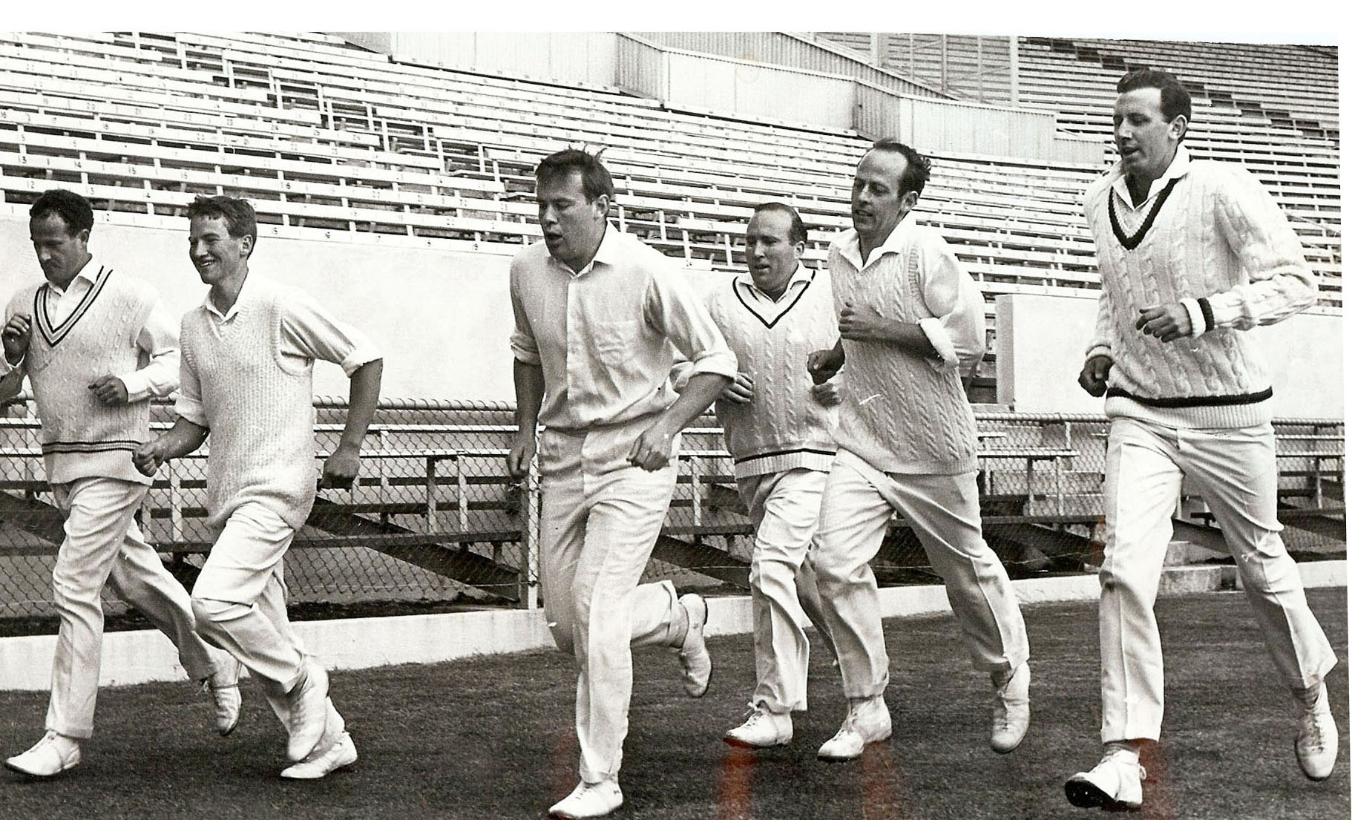

**Canterbury Cricket Representative Squad training at Lancaster Park November 1968**

**From left: JM McIntyre, JD Riley, RW Anderson, NA Huxford, BF Hastings, BR Taylor**